**PRACTICAL 6**

**AIM:**

Install the development environment to set up the Hyperledger Composer Playground.

**Tool Introduction:**

1. Hyperledger Composer Playground–
   * Hyperledger Composer is an extensive, open development toolset and framework to make developing blockchain applications easier. Our primary goal is to accelerate time to value, and make it easier to integrate your blockchain applications with the existing business systems. You can use Composer to rapidly develop use cases and deploy a blockchain solution in weeks rather than months. Composer allows you to model your business network and integrate existing systems and data with your blockchain applications.
   * Hyperledger Composer supports the existing Hyperledger Fabric blockchain infrastructure and runtime, which supports pluggable blockchain consensus protocols to ensure that transactions are validated according to policy by the designated business network participants.
   * Everyday applications can consume the data from business networks, providing end users with simple and controlled access points.
   * You can use Hyperledger Composer to quickly model your current business network, containing your existing assets and the transactions related to them; assets are tangible or intangible goods, services, or property. As part of your business network model, you define the transactions which can interact with assets. Business networks also include the participants who interact with them, each of which can be associated with a unique identity, across multiple business networks.

**Steps to install Hyperledger Composer Playground :**

1. To install Hyperledger Composer Playground, first we have to install prerequisites for it. To install prerequisites run below command into ubuntu cmd/Terminal.
   1. curl -O https://hyperledger.github.io/composer/latest/prereqs-ubuntu.sh
   2. chmod u+x prereqs-ubuntu.sh
   3. ./prereqs-ubuntu.sh

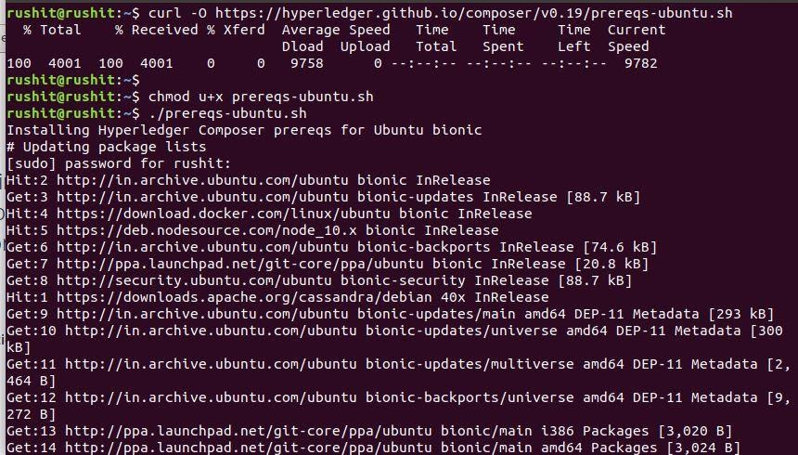

1. There are a few useful **CLI tools** for Composer developers. The most important one is **composer-cli**, which contains all the essential operations, so we'll install that first. Next, we'll also pick up **generator-hyperledger-composer**, **composer-rest-server** and **Yeoman**. Those last 3 are not core parts of the development environment, but they'll be useful if you're following the tutorials or developing applications that interact with your Business Network, so we'll get them installed now.

**Note: you should not use su or sudo for the following npm commands.**

1. Essential CLI tools:
   1. npm install -g [composer-cli@0.19](mailto:composer-cli@0.19)

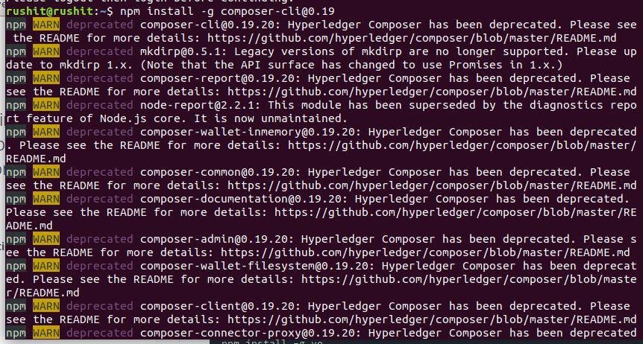

1. Utility for running a REST Server on your machine to expose your business networks as RESTful APIs:
   1. npm install -g composer-rest-server@0.19

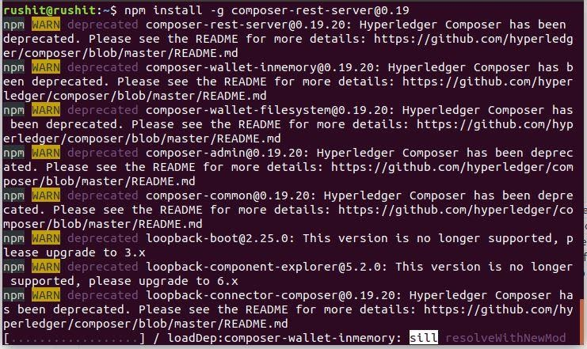

1. Useful utility for generating application assets:
   1. npm install -g [generator-hyperledger-composer@0.19](mailto:generator-hyperledger-composer@0.19)

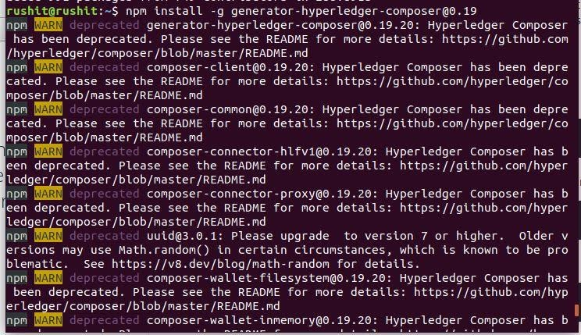

1. Yeoman is a tool for generating applications, which utilises generator-hyperledger-composer:
   1. npm install -g yo

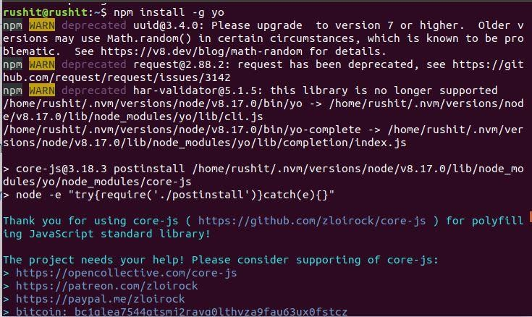

1. Now we will install playground. If you've already tried Composer online, you'll have seen the browser app "Playground". You can run this locally on your development machine too, giving you a UI for viewing and demonstrating your business networks.
2. Browser app for simple editing and testing Business Networks:
   1. npm install -g [composer-playground@0.19](mailto:composer-playground@0.19)

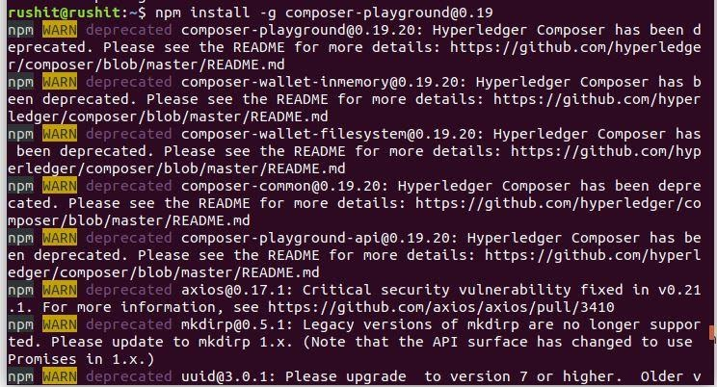

1. After installing playground, lets install hyperledger fabric.
2. In a directory of your choice (we will assume ~/fabric-dev-servers), get the .tar.gz file that contains the tools to install Hyperledger Fabric:
   1. mkdir ~/fabric-dev-servers && cd ~/fabric-dev-servers
   2. curl -O https://raw.githubusercontent.com/hyperledger/composer-tools/master/packages/fabric-dev-servers/fabric-dev-servers.tar.gz
   3. tar -xvf fabric-dev-servers.tar.gz

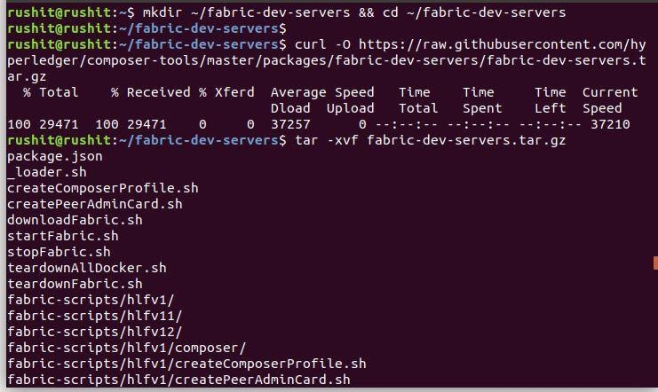

1. Use the scripts you just downloaded and extracted to download a local Hyperledger Fabric v1.2 runtime:
   1. cd ~/fabric-dev-servers
   2. export FABRIC_VERSION=hlfv12
   3. ./downloadFabric.sh

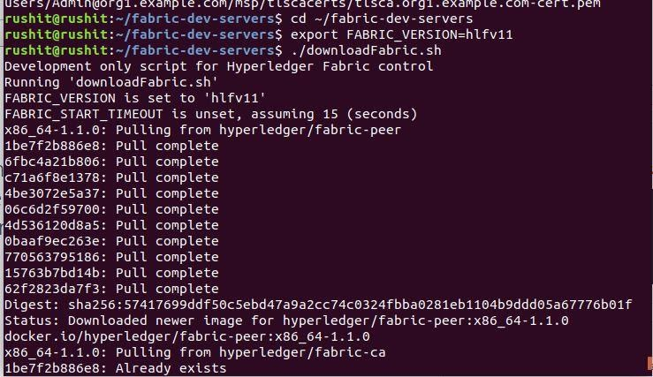

1. For the first time you start up a new runtime, you'll need to run the start script, then generate a PeerAdmin card:
   1. cd ~/fabric-dev-servers
   2. export FABRIC_VERSION=hlfv12
   3. ./startFabric.sh
   4. ./createPeerAdminCard.sh

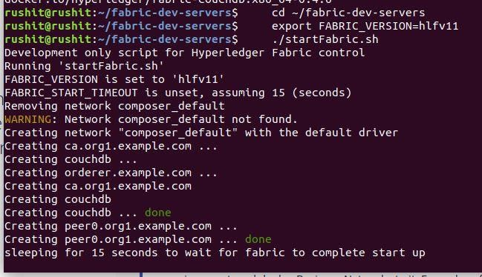

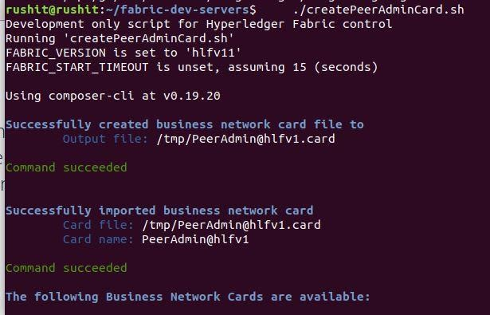

1. To start the web app, run:
   1. composer-playground

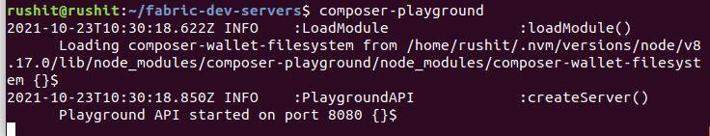

1. After running above step you will get an browser window that shown in the below images.

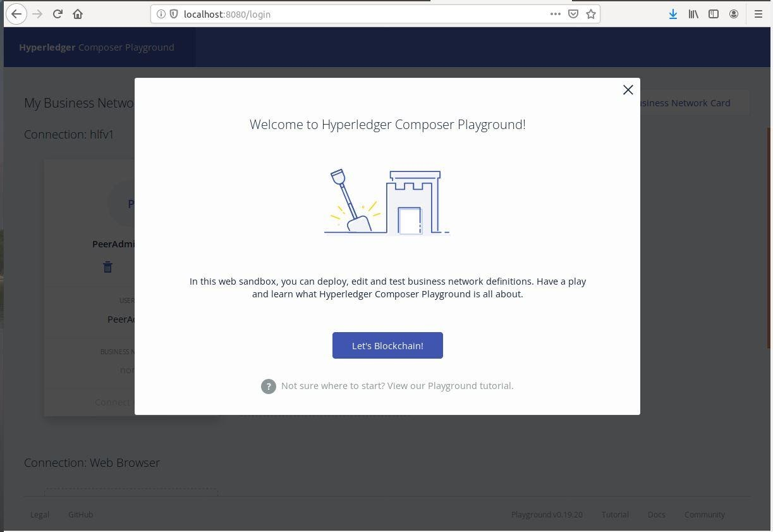

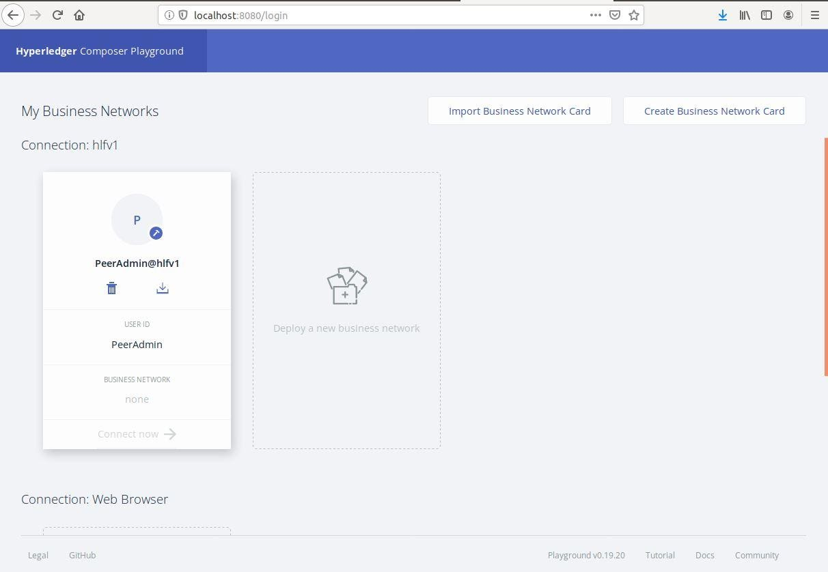

**CONCLUSION:**

In this practical, we learned about Hyperledger Composer Playground.